CHAPTER THREE
SYSTEM DESIGN AND SPECIFICATIONS
────────────────────
Design Framework, Requirements, Conceptual Development,
CAD Architecture, and Control System Logic

3.1 Research Design Framework
The design of the Vertical Form-Fill-Seal (VFFS) auger filling system follows a systematic engineering methodology that integrates requirements analysis, conceptual design, detailed engineering, and comprehensive validation through simulation. This structured approach ensures comprehensive coverage of all technical aspects while maintaining traceability from initial specifications to final implementation. The research design framework incorporates elements from established product development methodologies including Ulrich and Eppinger's Product Design and Development process and the V-model systems engineering approach [1].
The design process is organized into four sequential phases:
1. Requirements Definition - Establishment of functional requirements, performance specifications, and constraints based on application analysis and stakeholder needs.
2. Conceptual Design - Development of system architecture, functional decomposition, and selection of fundamental design concepts.
3. Detailed Design - Specification of component geometries, material selections, manufacturing processes, and control system architecture.
4. Design Validation - Verification of design adequacy through analytical modeling, numerical simulation, and correlation analysis.
This chapter addresses Phases 2 and 3, presenting the conceptual development and detailed specifications of the VFFS auger filling system. Chapter 4 presents the analytical modeling (Phase 4 validation methodology), while Chapter 5 documents the numerical simulation and correlation analysis.
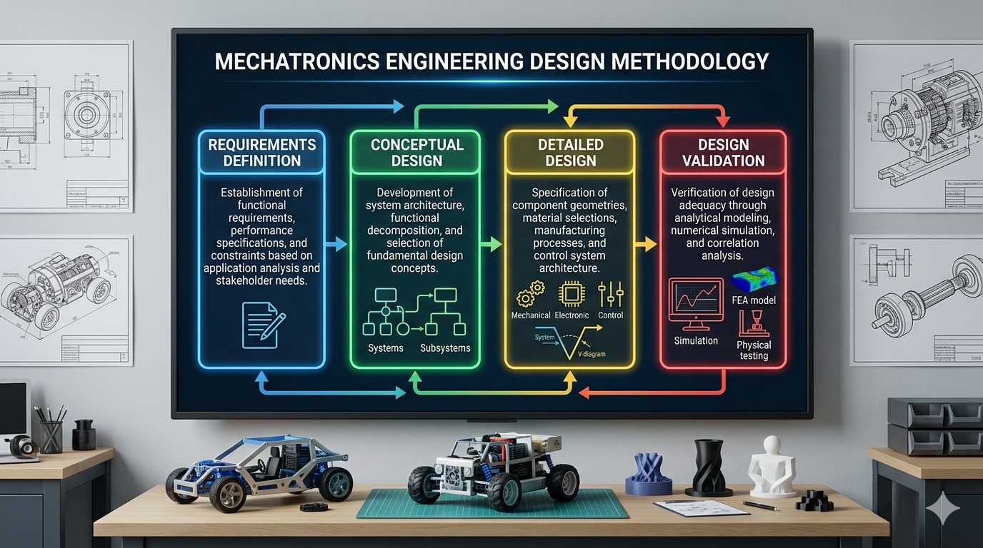
Figure 3.1: Design methodology flowchart showing the sequential phases from requirements definition through conceptual design, detailed design, and validation

3.2 Design Requirements and Constraints
Design requirements derive from the target application (packaging of 500g granular salt), industrial standards for food packaging machinery, and operational constraints imposed by the VFFS integration context. Requirements are categorized as functional (what the system must do) and non-functional (how the system must perform) [2].

3.2.1 Target Output (PPM: Packs Per Minute) and Accuracy (±σ)
The production throughput requirement establishes fundamental constraints on the mechanical and control system design. For the target application of 500g salt packaging, the following performance specifications are established:
• Target Production Rate: 20 bags per minute (20 PPM)
• Package Weight: 500 grams net content
• Weight Accuracy: ±1.5% .
• Filling Time: Maximum 2.0 seconds per cycle
• Cycle Time: 4.0 seconds total (including forming, sealing, and indexing)
The accuracy specification of ±1.5% aligns with OIML R87 international standards for prepackaged goods and represents typical industrial requirements for medium-value food products. Achieving this accuracy with volumetric dosing requires careful control of bulk density variation and precise angular positioning of the auger screw [3].
The filling time constraint of 2.0 seconds per cycle establishes the required auger rotational speed. Based on volumetric displacement calculations (detailed in Chapter 4), delivering 500g of salt requires approximately 4 revolutions of the auger. The required rotational speed is therefore:
N = (4 rev / 2 s) × 60 s/min = 120 RPM (nominal)
A design speed of 135 RPM is selected to provide margin for operational variation and to accommodate potential efficiency losses under adverse conditions.

3.2.2 Sanitary and Material Standards (e.g., AISI 304 Stainless Steel)
As a food packaging machine, all product-contact components must comply with applicable food safety regulations and hygienic design principles. Key requirements include:
Material Requirements:
• All product-contact surfaces: Food-grade stainless steel (AISI 304 minimum, AISI 316L preferred for salt applications)
• Surface finish: Ra < 1.6 μm for product-contact areas
• Corrosion resistance: Resistant to chloride-induced pitting (salt environment)
• No toxic materials: Compliance with FDA 21 CFR and EU Regulation 1935/2004
Hygienic Design Requirements:
• Smooth, continuous welds with no crevices for bacterial harborage
• Self-draining surfaces with no standing liquid zones
• Quick-disconnect components for cleaning access
• No dead zones where product can accumulate and degrade
• Compatibility with Clean-Out-of-Place (COP) procedures
Choosing AISI 316L stainless steel for all salt contact components provides superior chloride corrosion resistance compared to AISI 304. The molybdenum content (2-3%) in 316L forms protective oxide layers that resist pitting in saline environments, but due to the unavailability of AISI 316L stainless steel in Yemen, AISI 304 stainless steel was chosen, which also meets health requirements and food safety regulations [4].
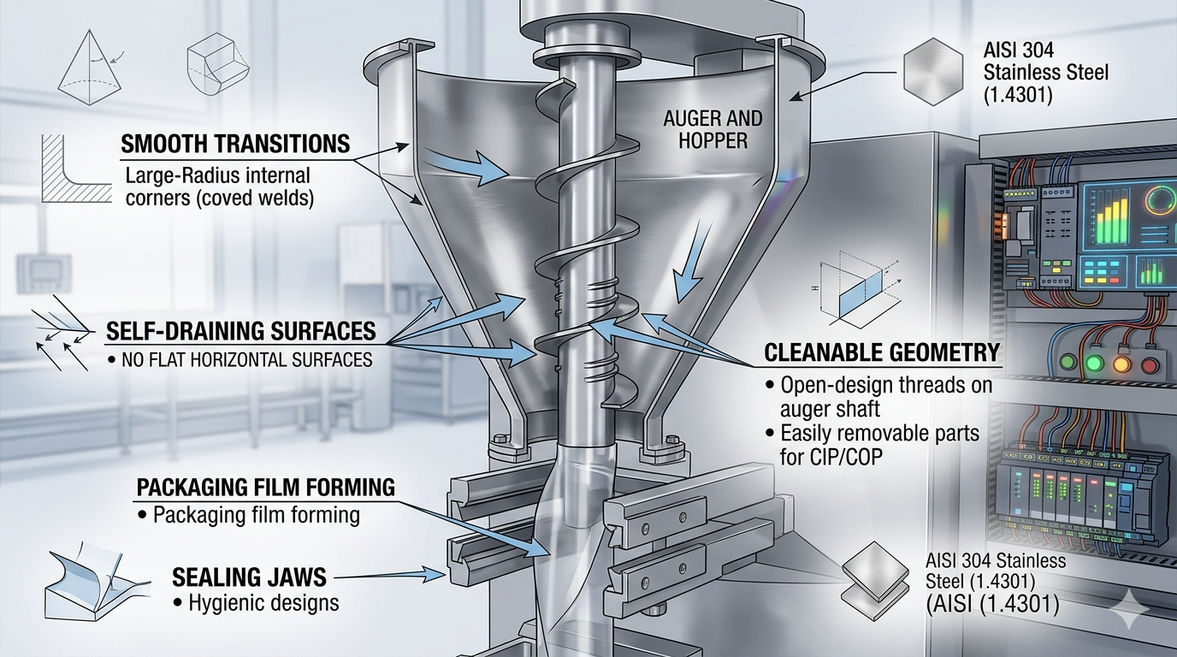Figure 3.2: Hygienic design principles for food-contact components, showing smooth transitions, self-draining surfaces, and cleanable geometry

3.3 Conceptual Development
Conceptual development transforms abstract requirements into concrete system architecture through functional decomposition and concept selection. This section presents the functional breakdown of the VFFS auger machine and the rationale for key design decisions.

3.3.1 Functional Decomposition (Dosing System, Packaging & Sealing System.)
- Dosing System Architecture :
The Dosing system is decomposed into four primary functional subsystems, each addressing specific aspects of the material handling and dosing process:

- Hopper Subsystem:
The hopper provides temporary storage of bulk material and ensures consistent feeding of the auger. Key design considerations include:
• Capacity: 20 L=16 kg for salt.
• Dimensions: Total Height (H) 330 mm , Top Diameter (Dtop) 446 mm, Outlet Diameter (Dout) 65 mm, Wall Angle (from horizontal) 60° .
• Geometry: Conical bottom with wall angle exceeding the angle of repose to ensure mass flow
• Material: AISI 304 stainless steel with electropolished interior surface
The hopper design incorporates a steep wall angle of 60° relative to the horizontal, which exceeds both the angle of repose (30-35°) and the wall friction angle (15-25°) of salt. This design ensures mass flow rather than funnel flow, preventing stagnation zones and maintaining consistent bulk density at the auger inlet.
- Agitator Subsystem:
The agitator prevents bridging and ratholing in the hopper while promoting consistent bulk density at the auger inlet. Design features include:
- Number of Blades: 2 (diametrically opposed at 180°)
- Dimensions: Upper Blade Position: 148.5 mm from top (45% of cone height), Lower Blade Position: 297 mm from top (90% of cone height), Blade Width: 60 mm , Blade Thickness: 8 mm
• Configuration: Counter-rotating paddle design sweeping the hopper periphery
• Speed: 30 RPM (independent drive from auger)
• Clearance: 3-5 mm from hopper walls to prevent interference
• Drive: DC motor .
The agitator performs three critical functions:
1. Bridge Breaking: Continuously destroys cohesive arches forming above the screw
2. Homogenization: Re-mixes fine and coarse particles to minimize segregation and stabilize bulk density
3. Force Feeding: Actively pushes powder toward the auger flights to ensure full screw filling in each revolution
- Agitator System and Coaxial Drive Architecture Design:
To ensure continuous mass flow and prevent bridging, the internal agitation system operates independently from the main auger screw. The design utilizes a highly specialized coaxial drive architecture that allows the central auger shaft (Blender Auger Long) to rotate at 135 RPM (CW) while the outer Blender Seat, which holds the Agitator / Blender blades, rotates simultaneously at 30 RPM (CCW).
This kinematic decoupling is achieved through a precision-engineered concentric assembly:
- Inner Transmission: The primary high-speed torque is transmitted through the Auger Shaft and the Blender Auger Long directly to the Auger Screw.
- Outer Transmission: The low-speed counter-rotation is driven by an independent motor housed in the Blender Motor Case. The torque is transmitted via a timing belt system utilizing an HTPA50S5M150-A-H40 driven pulley and a C-HTPA20S5M150-A-P15 drive pulley, which are connected to the Blender Seat
- Bearing Architecture and Mechanical Decoupling:
The fundamental challenge in this coaxial design is physically isolating the high-speed and low-speed rotational dynamics to prevent friction-induced torque transfer. This is resolved by an advanced bearing and sleeve configuration:
Inner Isolation (Shaft-to-Seat): Deep groove ball bearings (B6702ZZ and B6804ZZ) are press-fitted between the high-speed Blender Auger Long shaft and the intermediate Coupling Sleeve / Blender Seat. These bearings completely isolate the internal 135 RPM rotation from the external 30 RPM rotation.
Outer Support (Seat-to-Frame): The entire rotating agitator assembly is structurally supported by the Outer Bearing Seat, which is rigidly bolted to the Funnel Plate Seat and the Main Plate. Additional bearings (B6809ZZ and B6902ZZ) are placed between the Blender Seat and the Outer Bearing Seat, allowing the agitator to rotate smoothly relative to the stationary machine frame.
Axial Retention and Preload: To prevent any axial displacement or vibrations during the start-stop dosing cycles, precision locknuts (MUEN15 and MUEN45) are utilized. These locknuts secure the inner and outer bearing races, ensuring strict geometric alignment and preventing the tight radial clearance (1.5 mm) from deviating during operation.
Environmental Protection: All selected bearings feature double metal shields (ZZ designation). This is a critical design choice to prevent the highly abrasive and hygroscopic sodium chloride dust from penetrating the rolling elements, thereby extending the fatigue endurance of the mechanical assembly.
- Auger Subsystem:
The auger screw is the core dosing element, providing positive displacement metering of material. Key specifications include:
• Outer diameter: 60 mm
• Shaft diameter: 16 mm
• Pitch: 60 mm (square pitch configuration)
• Radial clearance: 1.5 mm maximum
• Material: AISI 304 stainless steel with electropolished flights
The auger geometry follows the square pitch configuration (pitch equal to outer diameter), which is optimal for free-flowing granular materials. This configuration provides stable flow with minimal particle segregation and predictable volumetric displacement.
- Discharge Nozzle and Spinner Plate:
The discharge mechanism controls material flow during and after the dosing cycle. The spinner plate provides flow cutoff when rotation stops, preventing dribble that would compromise weight accuracy. Design parameters include:
• Spinner plate diameter: 80 mm
• Clearance to funnel lip: 2-3 mm
• Operating speed: Synchronous with auger (135 RPM)
• Function: Centrifugal dispersion during rotation, angle-of-repose containment when stopped
The spinner plate operates on the principle of balance between centrifugal force and angle of repose. When the auger rotates, centrifugal force pushes salt particles radially outward through the gap between the plate and the funnel lip. Upon auger stop, centrifugal force vanishes, and the accumulated salt forms a "natural product dam" that prevents leakage without requiring complex mechanical valves.
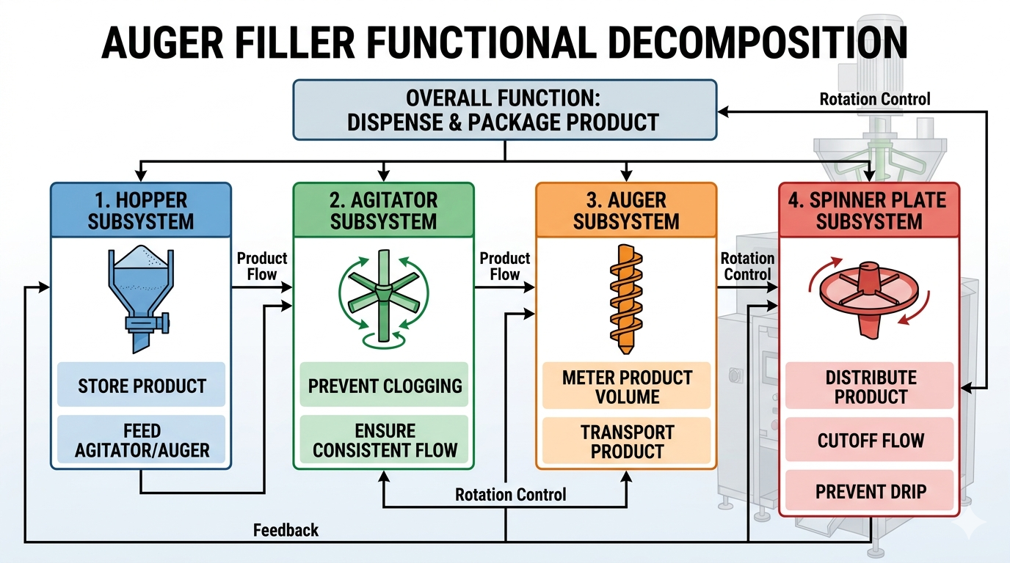
Figure 3.3: Functional decomposition diagram showing the four primary subsystems and their interactions
- Packaging and Sealing System Architecture:
The packaging subsystem transforms the planar thermoplastic film into a hermetically sealed pouch.
- Forming Tube Subsystem:
The forming tube constitutes the core component of the VFFS system, facilitating the optimal folding of the film.
• Dimensions: External diameter of 83 mm (yielding a 120 mm bag width + 10 mm seal), internal diameter of 77 mm, and an overall length of 400 mm.
• Forming Collar: Engineered with a 25° angle for optimal film folding fluidity.
• Manufacturing Details: Constructed from AISI 304 stainless steel with a highly polished surface ( $Ra≤0.4 mμ$) and a roundness tolerance of ±0.05 mm.
Figure 3.3: Forming tube and collar assembly, illustrating the 25° forming angle and the mounting flange
- Sealing Mechanisms (Horizontal & Vertical):
Thermal integrity is paramount for hygroscopic materials like NaCl.
• Horizontal Sealing Jaws: These 220 mm long jaws create the transverse seals and sever the pouch. They apply 300–500 N of force and utilize a 300W cartridge heater. The 8 mm sealing surface is bifurcated into dual 3 mm lines with a central groove for a 0.5 mm cutting blade, featuring a cross-hatch pattern (0.2 mm depth) for optimal grip.
• Vertical Sealing Bars: A 400 mm bar operating at 140–160°C under 3 Bar of pneumatic pressure. It features a 10 mm sealing width and a 3 mm PTFE thermal insulation layer, adjustable horizontally by ±15 mm.
- Film Handling and Pull Mechanism
This system extracts film from the supply roll with controlled velocity, precision, and modulated tension.
• Film Unwinder & EPC: Equipped with a mechanical brake for tension modulation, a dancer arm sensor for real-time feedback, and an Edge Position Control (EPC) photoelectric sensor driving a corrective servo/stepper actuator to maintain accurate film tracking.
• Pull Belt Assembly: Utilizes counter-rotating nip rollers (80 mm diameter, 300 mm width) coated in 60 Shore A durometer silicone rubber. Driven by a 450–750W servo motor with a 1:10 reduction ratio, ensuring precise kinematic synchronization.

- Pneumatic System Design:
VFFS pneumatic settings for different materials:
Component | Fiber 85 |  | Fiber 120 | Plastic 15-35 | Plastic 50
Seal jaws |  | 6 bars | 6 bars | 6 bars | 6 bars
Length seal |  | 5 bars | 5 bars | 5 bars | 5 bars
Belt transport |  | 5 bars | 5 bars | 5 bars | 6 bars
Film brake |  | 3 bars | 3 bars | 3 bars | 3 bars
Film tension |  | 2 bars | 1 bars | 0 bars | 4 bars
Table:3.3.1 1:VFFS pneumatic settings for different materials
Power and Utilities Requirements:
Utility | Specification |  | Consumption | Connection Size
Electrical Power |  | 1-phase, 220V, 50/60Hz | 1–4 kW total | 32A circuit breaker
Compressed Air |  | 6–8 bar, Dry, Oil-free | 50–100 L/min | 1/2" NPT
Cooling Water |  | 15–25°C, 2–4 L/min | 120–240 L/hr | 3/4" hose
Exhaust Ventilation |  | 500–1,500 m³/h | Product dependent | 150–200 mm duct
Table:3.3.1 2:Power and Utilities Requirements

3.3.2 Selection of Actuation (Servo-driven vs. Induction)
The selection of motor technology for auger drive represents a critical design decision affecting precision, cost, and system complexity. Three primary options were evaluated: induction motor with clutch-brake, stepper motor, and servo motor [5].
Option 1: Induction Motor with Clutch-Brake
Traditional auger fillers employed induction motors running continuously with mechanical clutch-brake mechanisms to control auger rotation. While mechanically simple and cost-effective, this approach suffers from significant limitations:
• Poor positioning accuracy due to clutch engagement variability
• Mechanical wear requiring frequent maintenance
• Limited dynamic response (slow acceleration/deceleration)
• Inability to implement advanced motion profiles
Option 2: Stepper Motor
Stepper motors provide open-loop position control without feedback devices. While offering improved positioning compared to clutch-brake systems, stepper motors exhibit several disadvantages:
• Risk of missed steps under load, causing cumulative positioning errors
• Limited torque at high speeds
• Audible noise and vibration at certain speeds
• No verification of actual position achieved
Option 3: Servo Motor (Selected)
Servo motor systems combine high-performance brushless motors with closed-loop feedback control, offering superior performance for precision dosing applications. The selected Panasonic MINAS A6 AC servo motor provides:
• 23-bit absolute encoder (8,388,608 pulses per revolution)
• High dynamic response (acceleration to rated speed in <50 ms)
• Full torque available across entire speed range
• Electronic cam and motion profile capability
• Real-time position verification and error correction
The servo motor is coupled to a 20:1 planetary gearbox, providing output speed of 135 RPM at the auger while multiplying motor torque by the gear ratio (minus efficiency losses). The planetary configuration offers high torque density, low backlash (<3 arcminutes), and efficient power transmission [6].
The selection of servo motor technology is justified by the following quantitative analysis:
Positioning Resolution:
The 23-bit encoder provides angular resolution of:
θ_res = 360° / 2^23 = 360° / 8,388,608 = 4.29 × 10^-5 degrees per count
For a 500g dose requiring 3.95 revolutions, the positioning error contribution to weight variation is:
Error = (4.29 × 10^-5°) × (3.95 rev) × (500g / 360°) = 2.35 × 10^-4 g
This negligible error confirms that servo positioning accuracy exceeds the requirements for ±1.5% dosing accuracy.
[Insert Figure 3.4 here]
Figure 3.4: Servo motor and planetary gearbox assembly showing encoder feedback, drive coupling, and mounting configuration

3.4 Final Mechanical Architecture (CAD)

The final mechanical design integrates all functional subsystems into a single, optimized unit that is easier to manufacture and maintain. This section presents the machine's mechanical design in the SolidWorks software.

3.4.1 Dosing System CAD:

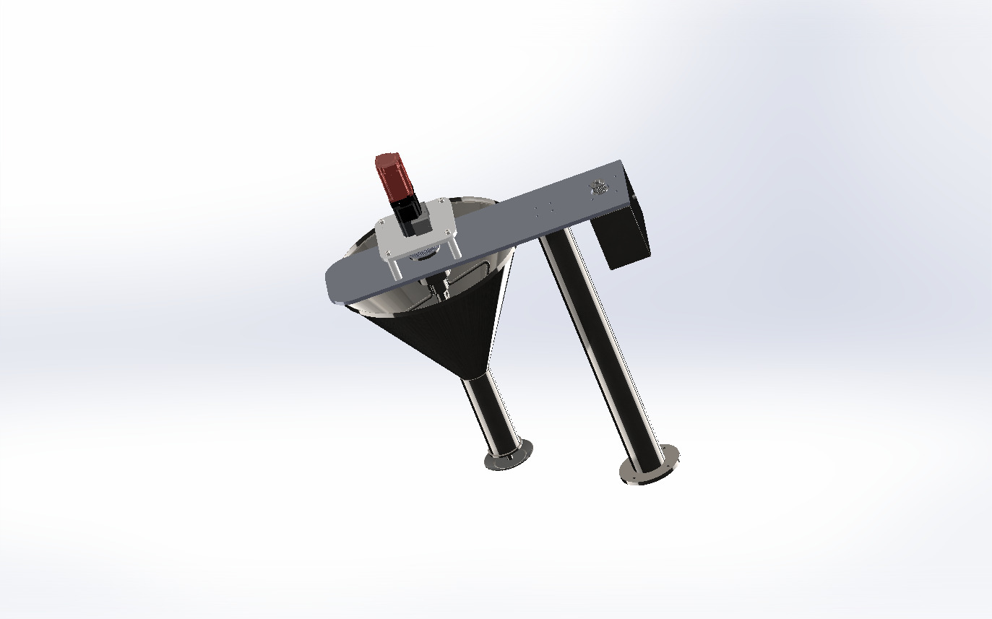
Figure:3.4.1 1 Dosing System CAD

- Final Hopper Dimensions:
Parameter | Value
Total Height (H) | 330 mm
Top Diameter (Dtop) | 446 mm
Outlet Diameter (Dout) | 65 mm
Wall Angle (from horizontal) | 60°
Wall Angle (from vertical) | 30°
Capacity | 20 L
Material | AISI 304L stainless steel
Tabel:3.4.1 1:Final Hopper Design Dimensions
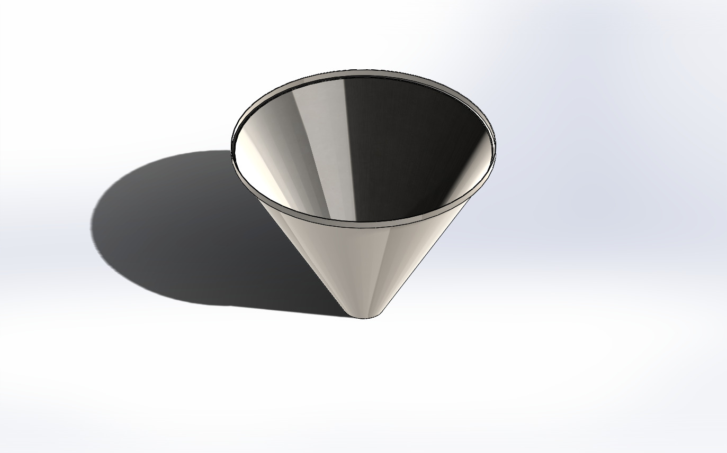
Figure:3.4.1 2Hopper CAD

- Final Blade Configuration
- Number of Blades: 2 (diametrically opposed at 180°)
- Blade Type: Skewed paddle with 25° rake angle
- Blade Width: 60 mm
- Blade Thickness: 8 mm
- Upper Blade Position: 148.5 mm from top (45% of cone height)
- Lower Blade Position: 297 mm from top (90% of cone height)
- • Material: AISI 304L stainless steel
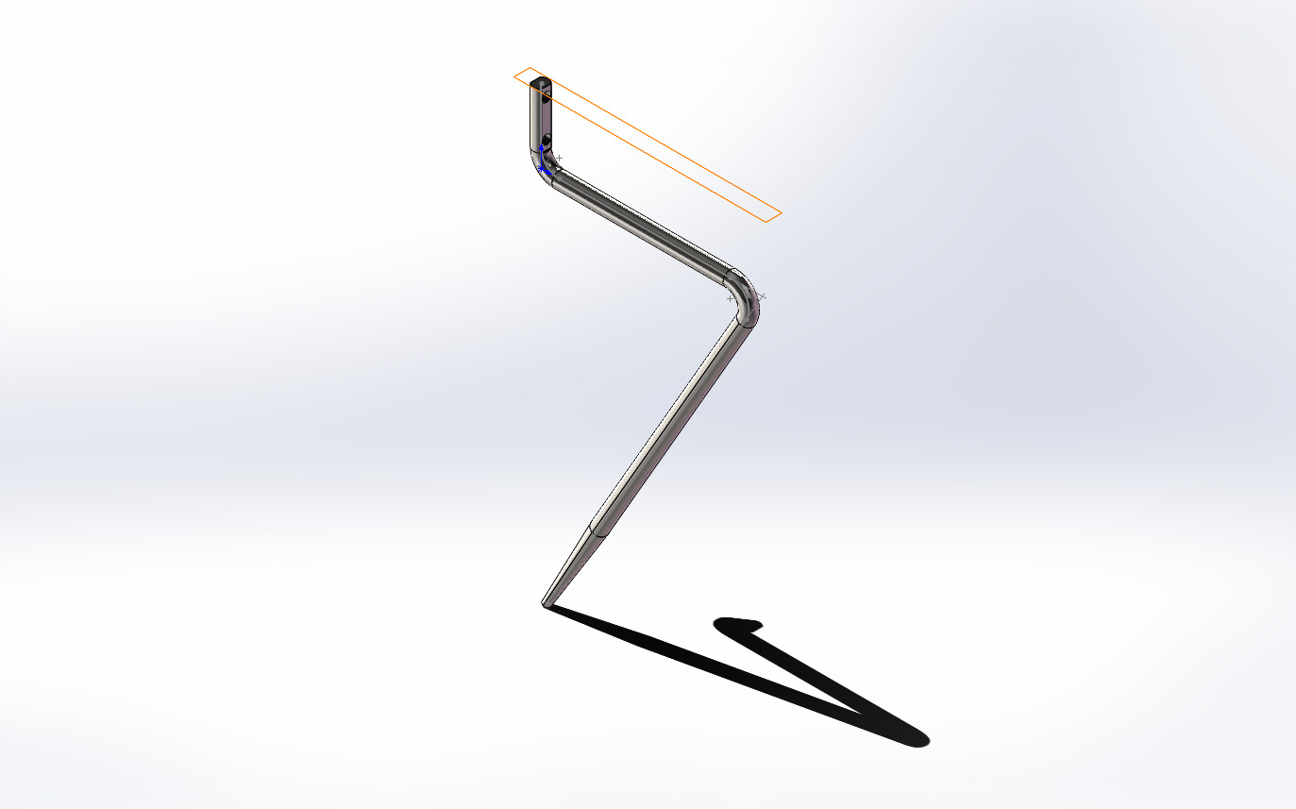
Figure:3.4.1 3Long Blade CAD
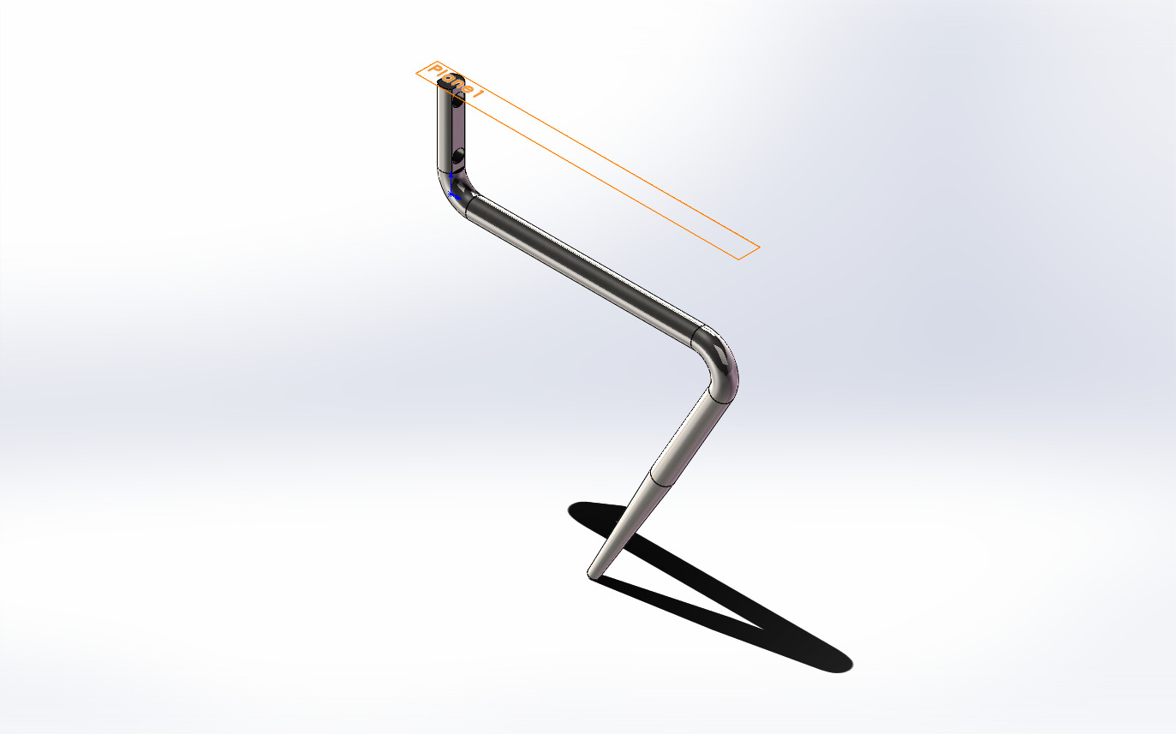
Figure:3.4.1 4Short Blade CAD
- Final Agitator System and Coaxial Drive Architecture Design:

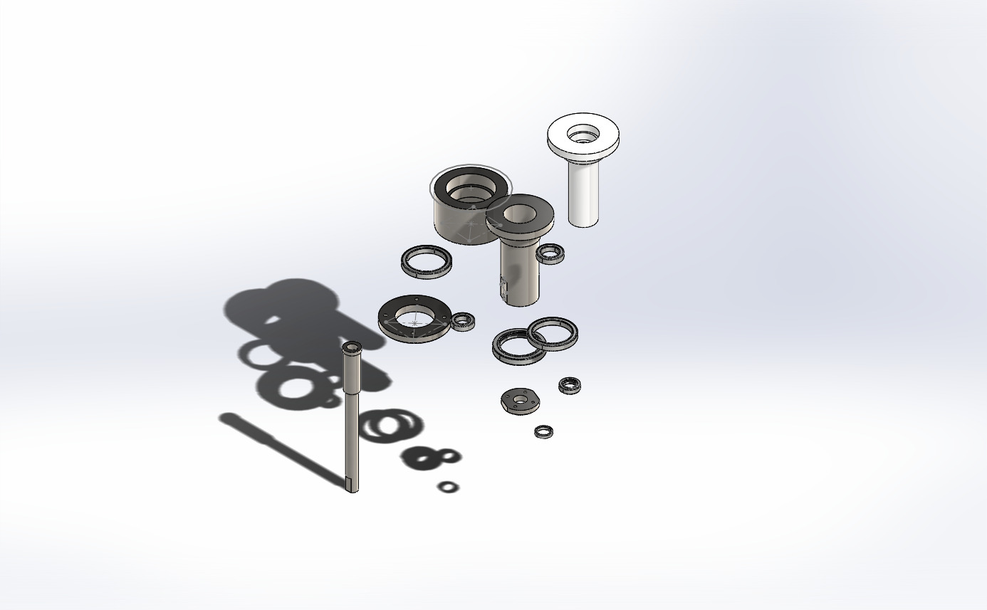
Figure:3.4.1 5Component Of Agitator Connection CAD
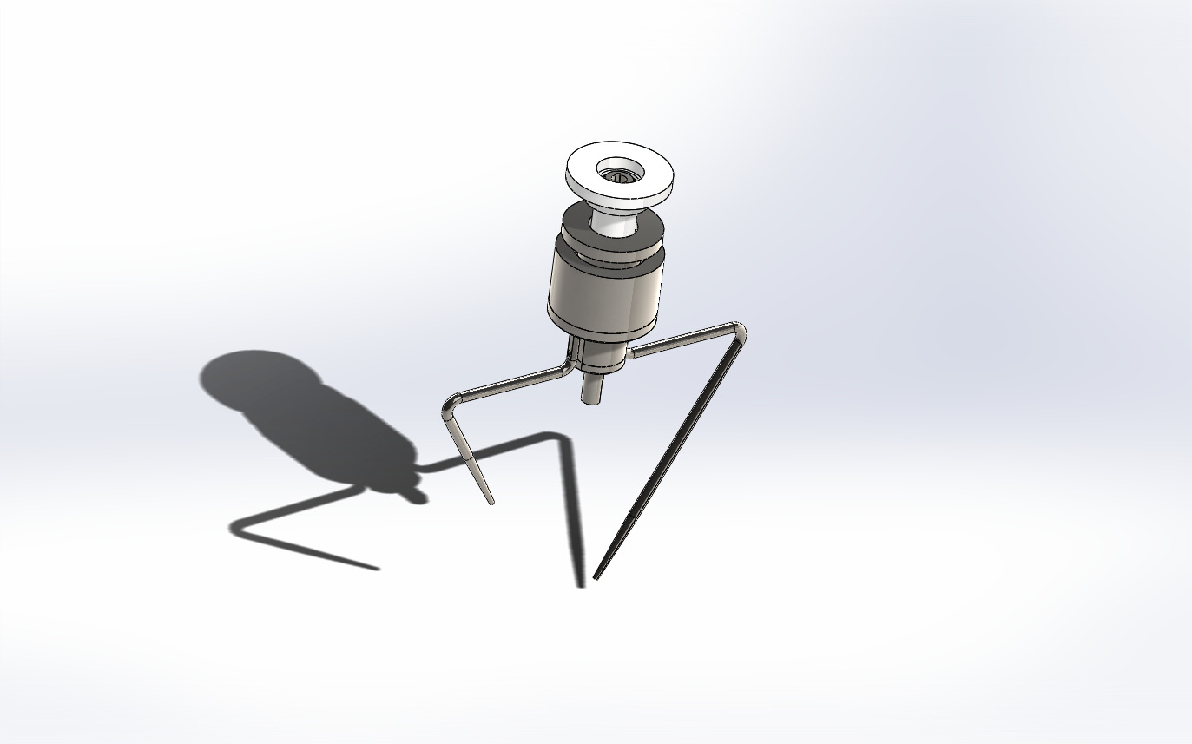
Figure:3.4.1 6Agitator System CAD

- Final Auger Screw Design:
The auger screw and surrounding funnel assembly constitute the core dosing mechanism. The design employs a straight (non-tapered) auger with square pitch geometry optimized for free-flowing granular materials.
Auger Screw Specifications:
• Outer diameter (D): 60 mm
• Shaft diameter (Ds): 16 mm
• Pitch (P): 60 mm
• Flight thickness: 3 mm
• Number of effective pitches: 4.5
• Overall length: 320 mm
• Material: AISI 304L stainless steel
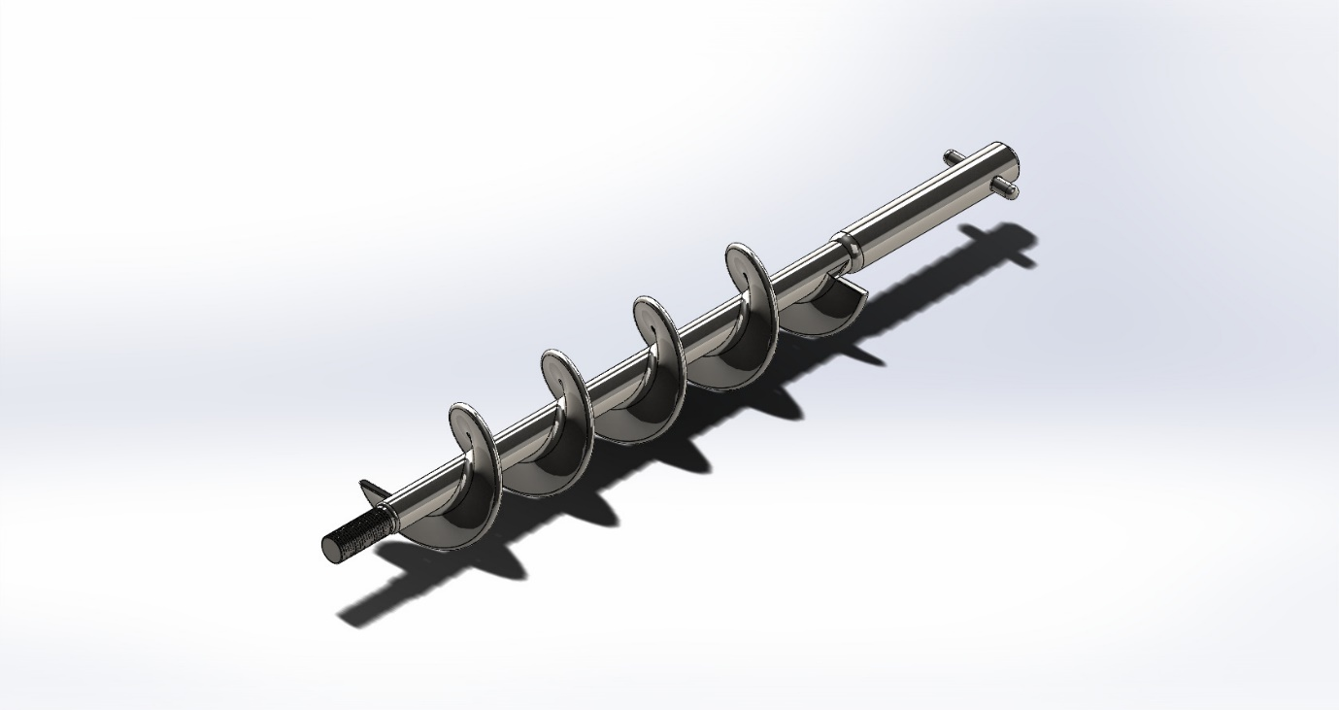
Figure:3.4.1 7Auger CAD
- Final Spinner plate :
• diameter: 80 mm
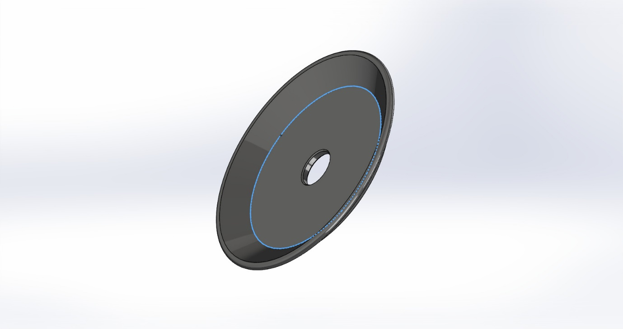
Figure:3.4.1 8Spinner Plate CAD

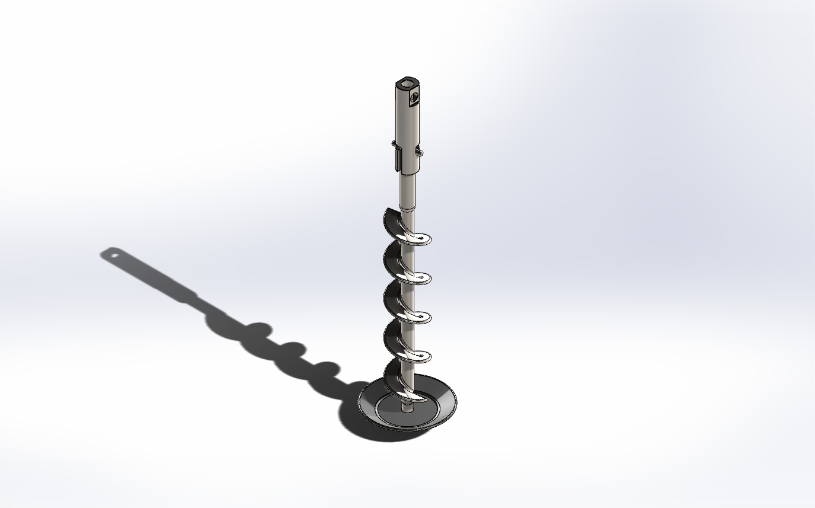
Figure:3.4.1 9Spinner Plate& Auger CAD

- Funnel Assembly Specifications:
• Inner diameter: 63 mm (providing 1.5 mm radial clearance)
• Length: 150 mm
• Material: AISI 304L stainless steel
The radial clearance of 1.5 mm between auger flight tip and funnel wall represents a compromise between dosing accuracy and manufacturing tolerance. Smaller clearance reduces backflow but increases risk of metal-to-metal contact due to thermal expansion or mechanical deflection. The 1.5 mm specification provides adequate margin while maintaining acceptable volumetric efficiency [7].
The clearance specification is validated through thermal expansion analysis:
ΔL = α × L × ΔT
Where α = 16.0 × 10^-6 /°C (thermal expansion coefficient for AISI 304L)
L = 280 mm (auger length)
ΔT = 42 - 25 = 17°C (maximum temperature rise)
ΔL = 16.0 × 10^-6 × 280 × 17 = 0.076 mm
The thermal expansion of 0.076 mm represents only 5% of the radial clearance, confirming adequate margin for thermal effects.
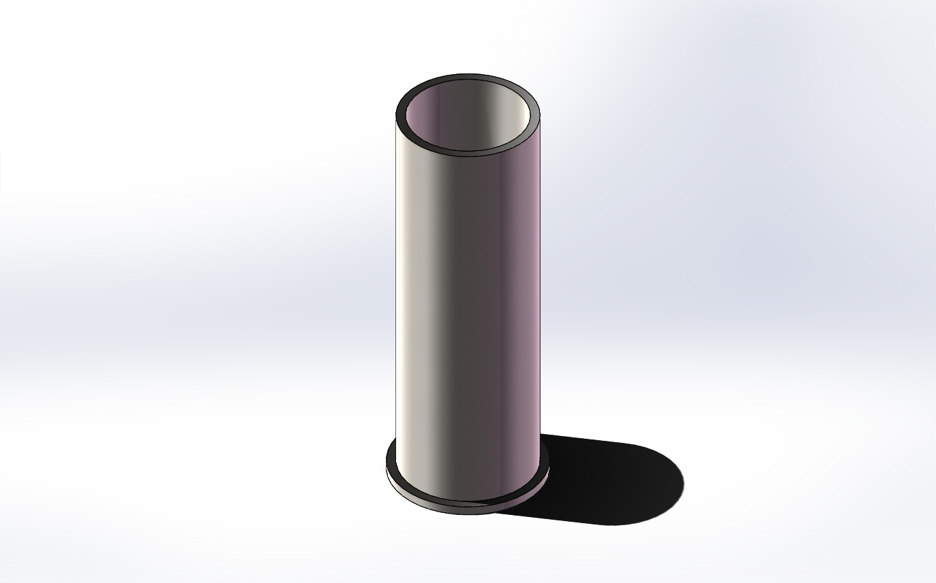
Figure 3.5: CAD model of funnel assembly

3.4.2 Packaging and Sealing System CAD:
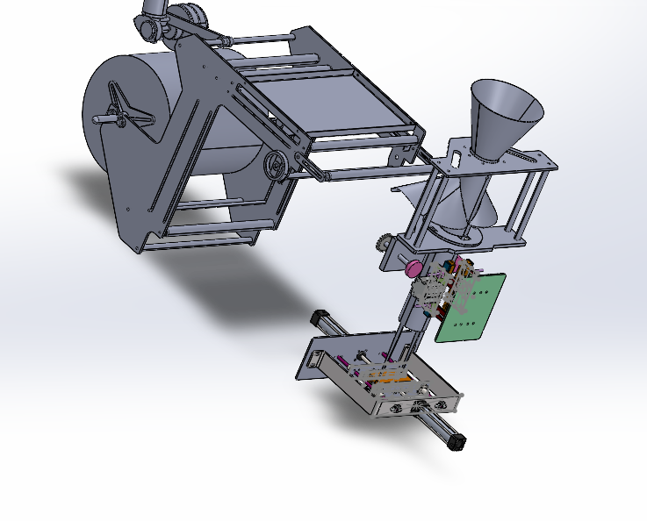
Figure:3.4.2 1Packaging and Sealing System CAD
- Final Forming Tube Design :
- External diameter: 83 mm (for producing 120 mm width bags + 10 mm seal)
- Internal diameter: 77 mm (wall thickness 3 mm)
- Overall length: 400 mm
- Forming zone length: 300 mm
- Collar angle: 25° for optimal film folding fluidity
- SolidWorks Design Procedure:
1. Primary Sketch: External circle Ø83 mm, Internal circle Ø78 mm, Extrude 400 mm
2. Detail Addition: Conical collar at 25° (Revolve Feature), Mounting holes 4×M8, Upper flange 10 mm
3. Finishing: Fillet radius 2 mm, Mirror Polish, Apply material SS 304L
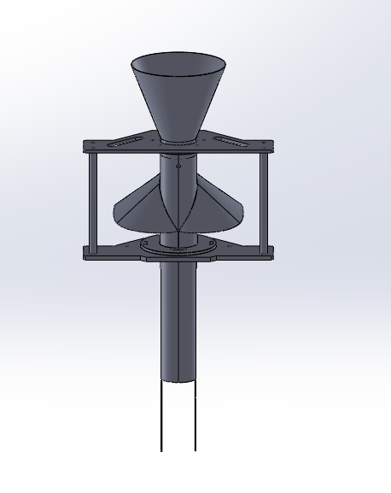
Figure:3.4.2 2Forming Tube CAD

- Final Horizontal Sealing Jaws Design:
  - Jaw length: 220 mm
  - Sealing surface width: 8 mm (bifurcated into dual 3 mm sealing lines with 2 mm central groove)
  - Stroke distance: 25 mm
  - Sealing force: 300–500 N
  - Heating system: 300W cartridge heating element
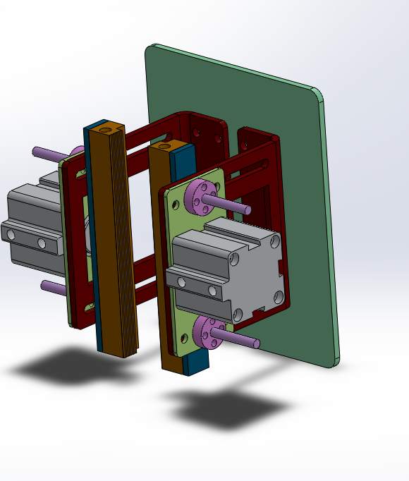
Figure:3.4.2 3Horizontal Sealing Jaws CAD
- Final Vertical Sealing Bars Design:
- Bar length: 400 mm
- Sealing surface width: 10 mm
- Pressure range: 3 Bar
- Operating temperature: 140–160°C
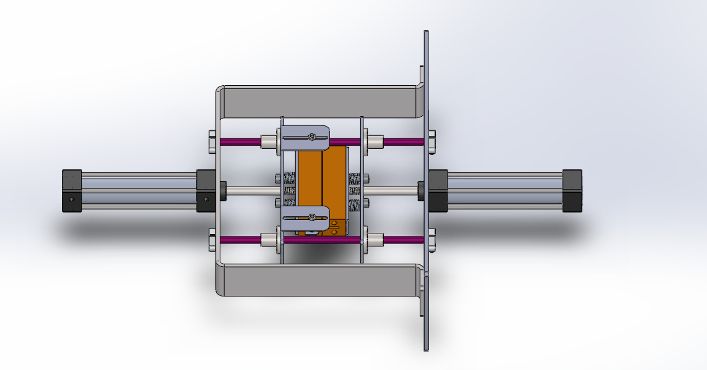
Figure:3.4.2 4Vertical Sealing Bars CAD
- Final Film Pull Mechanism Design:
  - Mechanism type: Counter-rotating nip rollers
  - Roller diameter: 80 mm
  - Roller width: 300 mm
  - Motor: 450–750W servo motor
  - Reduction ratio: 1:10
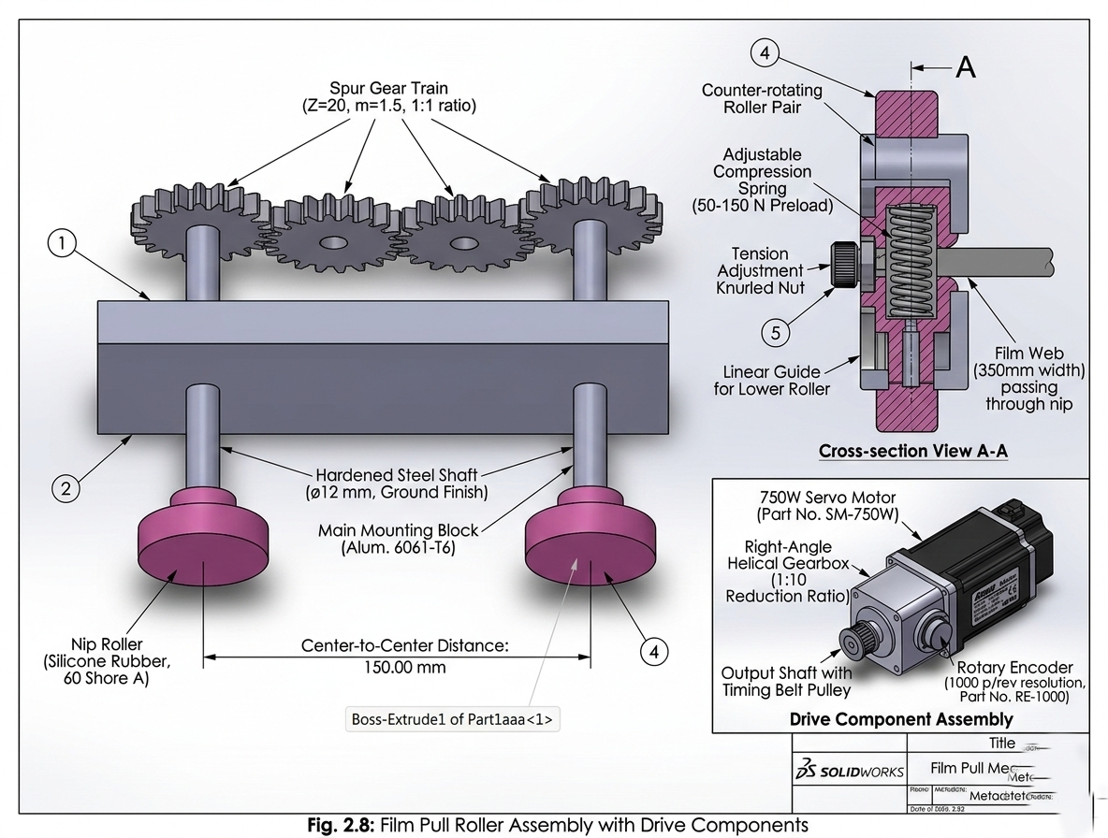
Figure:3.4.2 5Film Pull Mechanism CAD

3.4.2 Drive Train and Power Transmission
The drive train transmits power from the servo motor to the auger shaft while providing speed reduction and torque multiplication. The selected configuration comprises:
Prime Mover: Panasonic MINAS A6 AC Servo Motor
• Model: MSMF042L1U
• Rated power: 400W
• Rated torque: 1.27 N·m
• Maximum torque: 3.82 N·m
• Rated speed: 3000 RPM
• Encoder resolution: 23-bit absolute (8,388,608 pulses/rev)
Gearbox: Neugart PLE Planetary Gearbox
• Model: PLE 060
• Reduction ratio: 20:1
• Output torque (nominal): 25 N·m
• Output torque (maximum): 40 N·m
• Backlash: <3 arcminutes
• Efficiency: >97%
Power Transmission Calculations:
The effective output torque at the auger shaft is calculated as:
T_out = T_motor × i × η = 1.27 N·m × 20 × 0.97 = 24.6 N·m
Where i is the gear ratio and η is the gearbox efficiency. This output torque provides substantial margin above the calculated requirement of approximately 18-20 N·m under worst-case conditions, ensuring reliable startup even with compacted material [8].
The power transmission efficiency is validated through energy balance:
P_in = 400W (motor rated power)
P_out = T_out × ω = 24.6 N·m × (2π × 135/60) rad/s = 347 W
η_system = P_out / P_in = 347 / 400 = 86.8%
The system efficiency of 86.8% accounts for gearbox losses (3%), bearing friction (5%), and auger mechanical losses (5%).
[Insert Figure 3.6 here]
Figure 3.6: Drive train assembly showing servo motor, planetary gearbox, coupling, and auger shaft

3.4.3 Supporting Frame and Vibration Isolation
The mechanical frame provides structural support for all components while maintaining alignment critical to auger operation. Design considerations include:
Frame Structure:
• Frame material: Carbon steel with powder coat finish (non-contact areas)
• Upper mounting plate: 10 mm stainless steel for motor/gearbox mounting
• Hopper support: Tubular steel frame with tri-clamp bracket
• Load cell integration: Frame designed to accommodate weigh system if gravimetric feedback is added
Vibration Isolation:
Vibration isolation is achieved through the natural damping of the planetary gearbox and the rigid coupling between gearbox output and auger shaft. The counter-rotating agitator is mechanically isolated from the auger drive to prevent torque ripple transmission [9].
The frame design incorporates the following structural analysis considerations:
• Natural frequency of frame: >50 Hz (well above operating frequency of 2.25 Hz)
• Deflection under maximum load: <0.1 mm
• Safety factor for structural members: >3.0
[Insert Figure 3.7 here]
Figure 3.7: Complete mechanical assembly showing frame structure, motor mounting, hopper support, and auger assembly

3.4.4 Hopper and Agitator Design
The hopper design integrates material storage with active flow promotion through the agitator system.
Hopper Specifications:
• Capacity: 15 kg (30 minutes of operation at 15 PPM)
• Upper diameter: 400 mm
• Lower diameter: 150 mm (outlet)
• Wall angle: 60° from horizontal
• Material: AISI 316L stainless steel, 2 mm thickness
• Surface finish: Ra < 1.6 μm (2B finish)
Agitator Specifications:
• Configuration: Two counter-rotating paddles
• Paddle length: 180 mm
• Paddle width: 40 mm
• Speed: 60 RPM
• Motor: 90W AC gear motor with VFD
• Drive: Chain and sprocket transmission
The agitator design follows the principles established by Jenike and Schulze for cohesive material handling. The paddle tips operate at a peripheral speed of:
v = π × D × N / 60 = π × 0.36 × 60 / 60 = 1.13 m/s
This speed provides sufficient shear to break cohesive bridges without causing particle attrition or excessive power consumption.
[Insert Figure 3.8 here]
Figure 3.8: Hopper and agitator assembly showing paddle configuration and drive mechanism

3.5 Mechatronic System Architecture

The core of the control system lies in transforming the mechanical structure of the VFFS machine into an intelligent, deterministic system capable of synchronizing mechanical and thermal operations at high speeds with absolute reliability [14]. To ensure consistent seal quality during continuous operation, the thermal control subsystem was designed to maintain the sealing jaws at 150°C with a high precision of ±1°C [18]. Because the sealing process is heavily influenced by thermal inertia, heat losses, and continuous environmental fluctuations, a Model-Based Design (MBD) methodology was adopted to tune system performance, superseding traditional empirical trial-and-error methods.

3.5.1 Distributed Processing Strategy (Master-Slave Topology)

To mitigate the computational bottlenecks arising from simultaneous graphical rendering and thermo-kinetic control, a distributed control architecture was engineered utilizing two ESP32 microcontrollers [16]:

Master Node (Machine Controller): Acts as the "executive brain" of the machine. It is dedicated to executing the thermal PID algorithm, polling sensors, and generating motor pulses. This isolation guarantees that the machine's stability remains immune to any latency introduced by the user interface, fulfilling the requirements for rapid response and the elimination of steady-state error [14, 15].

Slave Node (HMI Controller): Functions as a dedicated graphical processor for the Human-Machine Interface (HMI), maintaining communication with the Master Node via a high-speed UART protocol [16, 20].
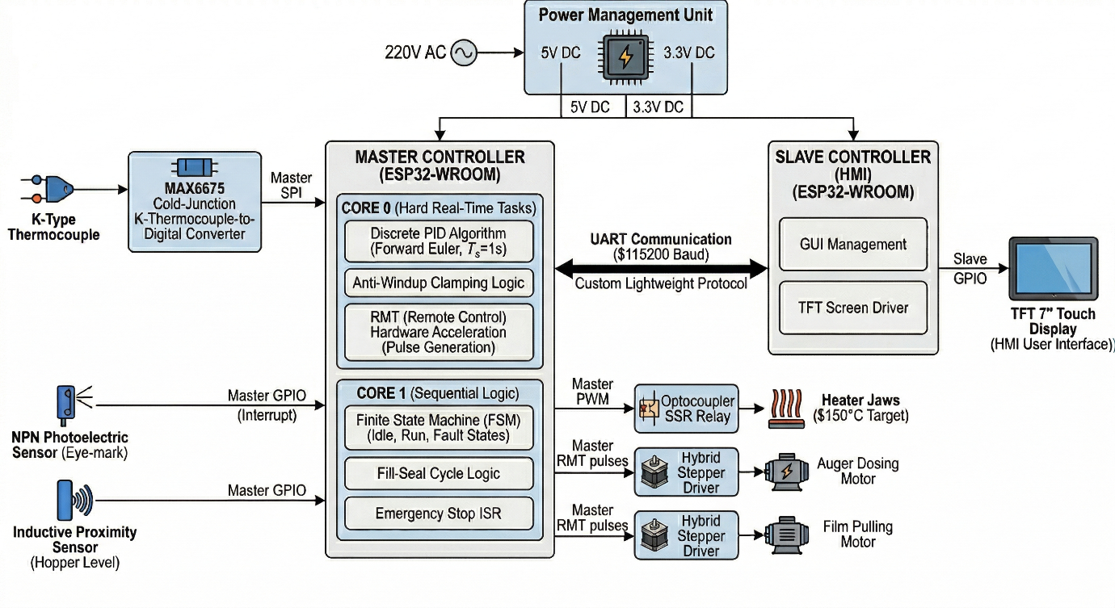Figure 3.1: General control system architecture block diagram showing the Master ESP32, Slave ESP32, sensors, SSR, and UART communication.

3.5.2 Operating System and Task Allocation (FreeRTOS & Dual-Core Strategy)

To achieve maximum stability, the dual-core processor of the ESP32 was leveraged via the FreeRTOS operating system to facilitate true multitasking [16, 17]. The core concept hinges on isolating precise hardware operations from application logic delays. Tasks were allocated according to strict priorities as follows:

Core 0 (Hardware & Time-Critical Tasks):

Fault Handler (Priority 5): Provides an instant response to Emergency Stop (E-STOP) interrupts, bypassing all software delays [17].

Motion Controller (Priority 4): Manages precise stepper motor control and pulse generation via the hardware RMT peripheral [16].

Thermal PID Controller (Priority 3): Executes the PID algorithm with a precise sample time of 1 second, an optimal duration for systems exhibiting significant thermal inertia [15, 19]. The controller's output is not utilized as a direct analog signal; instead, it is converted into Time-Proportional Control to drive the Solid State Relay (SSR) [15].

Core 1 (Application Logic & UI):

Control Loop (Priority 2): Manages the sequential logic of the machine via a Finite State Machine (FSM), including operational sequences and execution delays [17].

HMI (Priority 1): Handles button inputs, updates system status, and communicates with the Slave Node [20].

[Figure 3.2: Control signal flow diagram: Thermal Sensors → PID Algorithm → Time-Proportional Conversion → SSR]

3.5.3 Hybrid Motion Control Logic

In addition to thermal stability, the system demands stringent kinematic precision to ensure consistent productivity [21]. A two-phase motion strategy was innovated for the stepper motors:

Blind Zone Phase: The packaging film is pulled at maximum speed utilizing the hardware RMT peripheral. This generates highly precise waveforms without consuming CPU cycles, thereby maximizing system efficiency [16].

Search Zone Phase: The system transitions into a precise software-stepping mode to poll the registration "eye-mark" sensor after every individual microstep, ensuring the alignment of the bag with the cutting blade with micrometric accuracy [18].

3.5.4 Software Architecture of the Finite State Machine (FSM)

The operational firmware was structured based on a Finite State Machine (FSM) model, providing deterministic stability when transitioning between packaging phases [21]:

Idle State: Actively monitors the sealing jaw temperature and the salt level within the hopper.

Parallel Pull & Fill State: Concurrently executes the film pulling and auger rotation to minimize the overall cycle time [21].

Seal & Cut State: Actuates the pneumatic valves based on precisely defined timing intervals.

3.5.5 Industrial Isolation and Signal Integrity

Given the severe electromagnetic noise generated by the heaters and motors, the hardware interface was designed to ensure the highest degree of reliability:

Galvanic Isolation: Optocouplers are utilized to separate the sensitive 3.3V control circuits from the 24V motors and pneumatic valves.

Zero-Crossing Thermal Control: The implementation of a Solid State Relay (SSR) featuring Zero-Crossing prevents electrical grid interference when applying the time-proportional control frequencies generated by the PID controller.

3.5.6 Industrial Reliability and Protection Protocols (Fail-Safe Logic)

The control system is engineered to withstand continuous thermal and mechanical disturbances without inducing undesirable oscillations or ringing [14, 15]. To guarantee this, stringent software and hardware protection layers were integrated:

Emergency Stop (E-Stop) System: The emergency button is hardwired to a hardware Interrupt Service Routine (ISR) that preempts all system tasks, immediately halting motor pulses and de-energizing the SSR relays [17].

Integrator Anti-Windup Clamping: A saturation algorithm was embedded to prevent the excessive accumulation of integral error in the PID equation during the cold-boot heating phase. Simulation results of the closed-loop step response demonstrated the efficiency of this algorithm, achieving a settling time of 225.3 seconds with a negligible, near-zero overshoot of 0.3041%. The peak temperature reached only 150.45°C, confirming absolute system stability at the 150°C setpoint [14, 15].

Sensor Failure Cutoff: The system immediately cuts power to the heaters if the SPI bus reports a failure in reading the thermocouple data.

Over-Temperature Protection: A hard ceiling for temperature was programmed, which completely shuts down the system if exceeded, ensuring the Teflon tape does not burn and the sealing jaws are protected from thermal damage.

3.7 Summary of Design Specifications
Table 3.1 summarizes the key design specifications for the VFFS auger filling system:
Table 3.1: Summary of Design Specifications
Parameter | Specification | Unit
Production Rate | 20 | PPM
Package Weight | 500 | g
Weight Accuracy | ±1.5 | %
Filling Time | 2.0 | s
Auger Diameter | 60 | mm
Auger Pitch | 60 | mm
Shaft Diameter | 16 | mm
Radial Clearance | 1.5 | mm
Operating Speed | 135 | RPM
Motor Power | 400 | W
Gear Ratio | 20:1 | -
Hopper Capacity | 20 | L
Agitator Speed | 60 | RPM
Material | AISI 304L | -
Surface Finish | Ra < 0.8 | μm
The design specifications presented in this chapter provide the foundation for the analytical modeling and numerical simulation presented in subsequent chapters. The integration of mechanical design, control system architecture, and VFFS compatibility ensures that the system meets all target performance requirements.

3.6 Electronic Control System Design

3.6.1 System Architecture Overview
The electronic control system for the Vertical Form-Fill-Seal (VFFS) packaging machine is designed as a three-layer hierarchical architecture to ensure reliable operation in industrial environments. This architecture separates logic control, power interfacing, and high-power actuation to protect sensitive components from electrical noise and transients.
The first layer comprises the main controller (ESP32 microcontroller) operating at 3.3V DC, handling all computational tasks, sensor data acquisition, and communication protocols. The second layer consists of power interface modules including stepper motor drivers (A4988), Darlington transistor arrays (TIP122) for solenoid control, and solid-state relays for heating elements. These modules translate low-voltage logic signals into power signals capable of driving actuators. The third layer contains the high-power loads including stepper motors, pneumatic solenoid valves, and resistive heating elements operating at 12V-24V DC and 220V AC.
This layered approach provides galvanic isolation between the sensitive microcontroller and the noisy industrial power environment, ensuring signal integrity and system longevity.
3.6.2 Signal Isolation and Conditioning

3.6.2.1 Optical Isolation Using PC817
Industrial packaging machinery generates significant electromagnetic interference (EMI) from motor switching, solenoid actuation, and heater cycling. To protect the ESP32 from these disturbances, optical isolation is implemented for all sensor inputs using PC817 optocouplers.
The PC817 provides 5kV isolation between input and output sides, with a Current Transfer Ratio (CTR) ranging from 50% to 600%. The input side operates at 5V with a series current-limiting resistor, while the output side interfaces with the 3.3V logic of the ESP32.

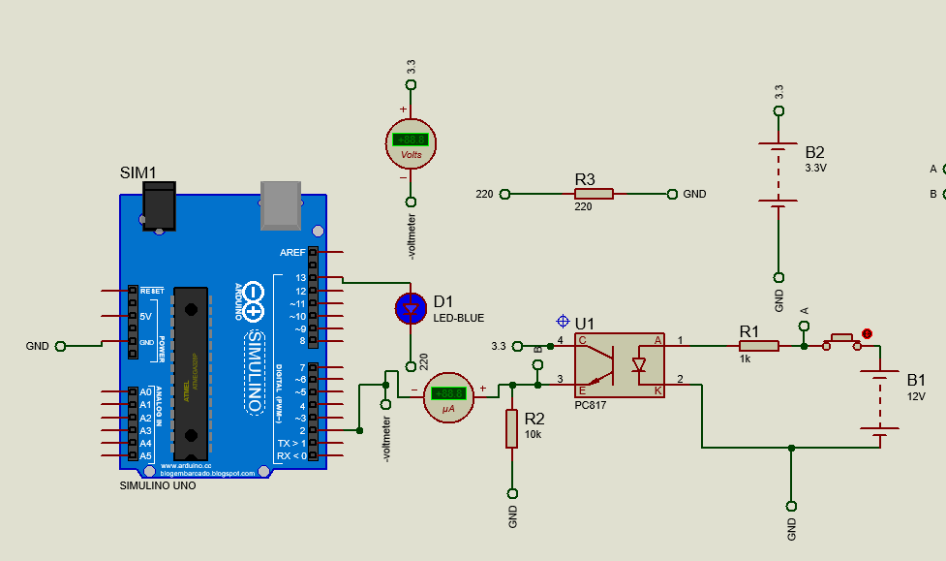
1Figure 3.1: PC817 Optocoupler Circuit Schematic
Figure 3.1 Caption: Optical isolation circuit using PC817 optocoupler showing input current limiting resistor (220 Ohm), LED anode/cathode connections, phototransistor collector/emitter configuration, and 10k Ohm pull-up resistor to 3.3V supply.
The input current is calculated to ensure reliable LED operation without excessive power dissipation:
IF = (Vsupply - VF_LED) / Rinput
IF = (5V - 1.2V) / 220 Ohm
IF = 3.8V / 220 Ohm
IF = 0.0173 A = 17.3 mA
Where:
IF = Forward current through LED (17.3 mA)
Vsupply = Supply voltage (5V)
VF_LED = LED forward voltage drop (1.2V)
Rinput = Current limiting resistor (220 Ohm)
This current provides sufficient illumination for reliable phototransistor activation while maintaining LED longevity. The 10k Ohm pull-up resistor on the output side ensures defined logic levels, providing approximately 0.33mA collector current when the transistor saturates, yielding a low logic level below 0.3V.

Parameter | Symbol | Value | Unit | Notes
Isolation Voltage | V\_ISO | 5000 | V | Between input and output
Forward Current | I\_F | 17.3 | mA | Calculated for LED operation
Current Transfer Ratio | CTR | 100 | % | Typical value at 25 deg C
Output Pull-up Resistor | R\_pullup | 10 | kOhm | Ensures defined logic high
Response Time | t\_r | 18 | us | Suitable for industrial control
Collector Current | I\_C | 0.33 | mA | At saturation, V\_CE approx 0.2V
1Table 3.1: PC817 Optocoupler Specifications and Operating Parameters

Table 3.1 Caption: Operating parameters for PC817 optocoupler in sensor interface applications, showing calculated values for current limiting and pull-up resistors to ensure reliable signal transmission with 3.3V logic compatibility.

3.6.2.2 Sensor Interface Circuits
Two primary sensors require optical isolation: the Eye Mark sensor for film registration and the Hopper Level sensor for salt quantity monitoring.
The Eye Mark sensor interface utilizes GPIO39 on the ESP32, with the optocoupler output configured as active-low. When the sensor detects the registration mark on the packaging film, the phototransistor conducts, pulling GPIO39 to logic low. This configuration provides noise immunity for the critical film positioning function.
The Hopper Level sensor employs GPIO35 with identical isolation circuitry. This sensor prevents dry-running of the auger motor by detecting low salt levels, protecting mechanical components from damage.

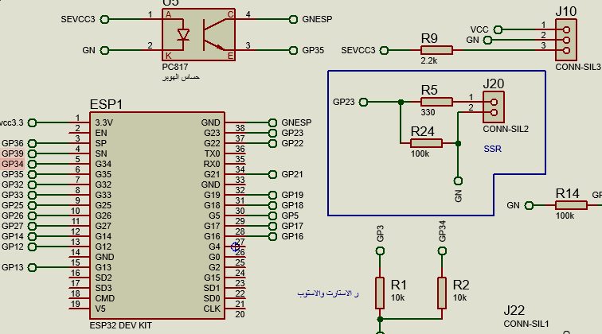
2Figure 3.2: Sensor Interface Circuit Board Layout
Figure 3.2 Caption: Printed circuit board layout showing placement of PC817 optocouplers with 8mm creepage distance between high-voltage sensor side (5V/24V) and low-voltage microcontroller side (3.3V), demonstrating compliance with IPC-2221B clearance requirements.

3.6.3 Temperature Measurement System

3.6.3.1 MAX6675 Thermocouple Interface
Precise temperature control is essential for heat-sealing operations in salt packaging. The system employs Type-K thermocouples interfaced with MAX6675 cold-junction-compensated thermocouple-to-digital converters. This integrated circuit eliminates the need for analog signal conditioning by providing direct digital temperature readings via Serial Peripheral Interface (SPI) protocol.
The MAX6675 operates with 12-bit resolution (0.25 deg C per count) over a range of 0 deg C to 1024 deg C, sufficient for sealing jaw applications typically operating at 150-250 deg C. Cold-junction compensation is performed internally, correcting for temperature variations at the connection terminals.

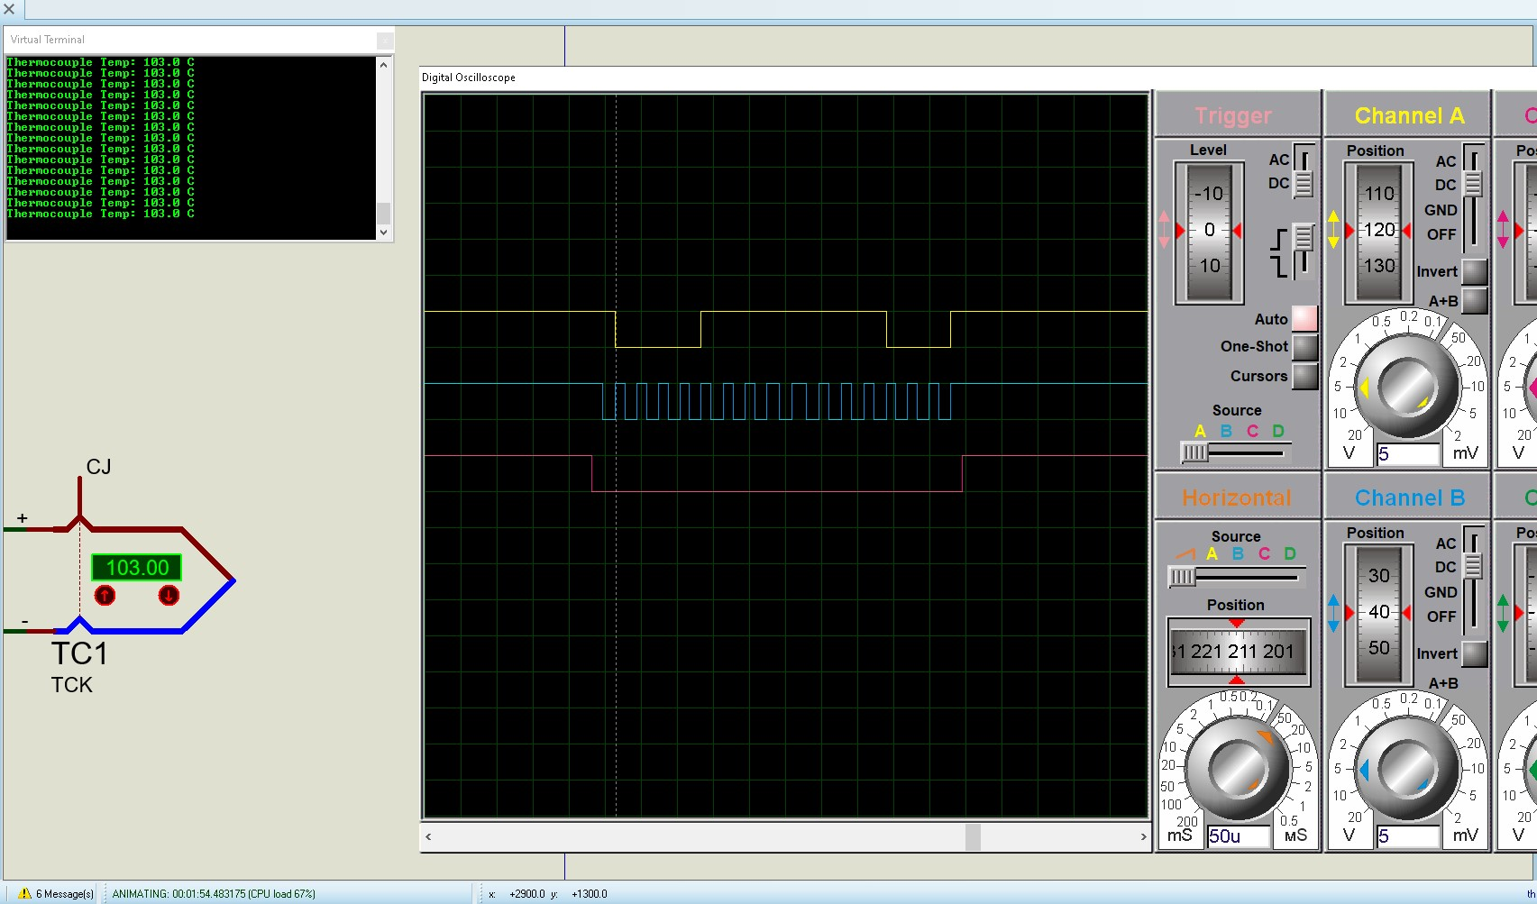
3Figure 3.3: MAX6675 SPI Communication Timing Diagram
Figure 3.3 Caption: Oscilloscope capture of SPI communication between ESP32 and MAX6675 temperature converter, showing clock signal (SCK, 100 kHz), chip select activation (CS), and serial data output (SO) with 16-bit temperature data frame.
The SPI interface connections are configured as follows:
MAX6675 Pin | ESP32 GPIO | Function | Description
SCK | GPIO18 | Serial Clock | Synchronization signal for data transfer
SO | GPIO19 | Serial Output | Temperature data from MAX6675 to ESP32
CS (Vertical) | GPIO22 | Chip Select 1 | Selects vertical sealing jaw thermocouple
CS (Horizontal) | GPIO21 | Chip Select 2 | Selects horizontal sealing jaw thermocouple
VCC | 3.30V | Power Supply | Logic supply voltage
GND | GND | Ground | Common reference
2Table 3.2: MAX6675 SPI Interface Pin Assignment

Table 3.2 Caption: SPI bus pin assignment for dual MAX6675 temperature measurement system, utilizing shared clock and data lines with individual chip select signals for independent reading of vertical and horizontal sealing jaw temperatures.
The temperature calculation from raw SPI data follows the manufacturer's specification:
T_Celsius = (Raw_Data >> 3) / 4
Where:
T_Celsius = Temperature in degrees Celsius
Raw_Data = 16-bit value read from MAX6675
3 = Right shift by 3 bits (removes status flags)
/ 4 = Division by 4 (accounts for 0.25 deg C resolution)
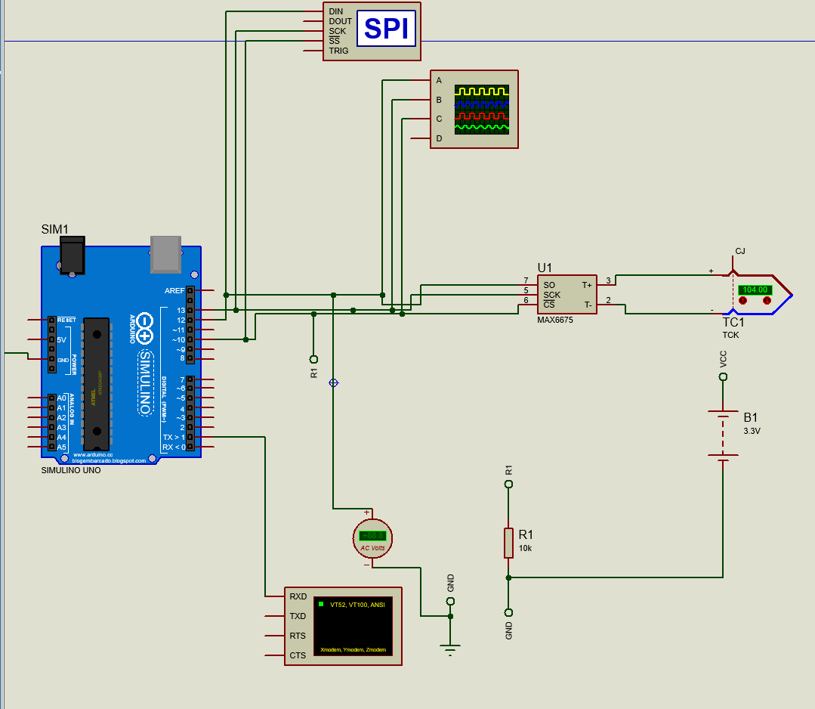
4Figure 3.4: Thermocouple Interface PCB Section

Figure 3.4 Caption: PCB layout detail for thermocouple interface section showing dual MAX6675 converters with dedicated chip select routing, decoupling capacitors (100nF ceramic), and thermocouple connector placement with ferrite bead filtering for EMI suppression.
3.6.4 Power Actuator Drivers
3.6.4.1 Solenoid Valve Drivers (TIP122)
Pneumatic actuation for the cutting knife and sealing jaws requires driving inductive loads (solenoid coils) from 3.3V logic signals. The TIP122 Darlington pair transistor is selected for this application due to its high current gain (hFE >= 1000) and ability to switch currents up to 5A.
The Darlington configuration provides two-stage current amplification, allowing the ESP32 GPIO (maximum 12mA source current) to control solenoids drawing 0.5-1A at 24V DC.
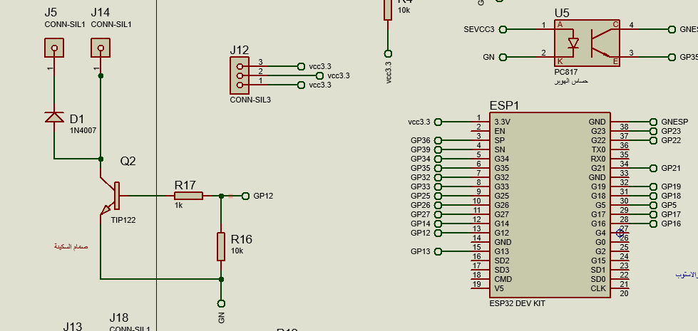
5Figure 3.5: TIP122 Solenoid Driver Circuit
Figure 3.5 Caption: TIP122 Darlington transistor solenoid driver circuit showing base current limiting resistor (1k Ohm), flyback protection diode (1N4007) across inductive load, and emitter-grounded configuration for low-side switching of 24V pneumatic solenoid valve.

Base resistor calculation ensures sufficient drive current for saturation:
R_base = (V_GPIO - V_BE_total) / I_B
Where:
R_base = Base resistor value (Ohm)
V_GPIO = GPIO output voltage (3.3V)
V_BE_total = Total base-emitter voltage drop (1.4V)
I_B = Required base current (A)
The base current is calculated with safety factor:
I_B = I_C / (hFE x SF)
I_B = 1A / (1000 x 1.5)
I_B = 1A / 1500
I_B = 0.00067 A = 0.67 mA
Where:
I_B = Base current (A)
I_C = Collector current (1A, solenoid nominal current)
hFE = Current gain (1000)
SF = Safety factor (1.5)
Yielding:
R_base = (3.3V - 1.4V) / 0.67 mA
R_base = 1.9V / 0.00067 A
R_base = 2836 Ohm = 2.8 kOhm

A standard value of 1 kOhm is selected to provide adequate margin while protecting the ESP32 GPIO from overcurrent conditions.
Parameter | Symbol | Value | Unit | Calculation/Notes
Collector Current | I\_C | 1.0 | A | Solenoid nominal current
Current Gain | hFE | 1000 | - | Minimum Darlington gain
Safety Factor | SF | 1.5 | - | Ensures deep saturation
Base Current | I\_B | 0.67 | mA | I\_C / (hFE x SF)
Base Resistor | R\_base | 1.0 | kOhm | Standard value with margin
Saturation Voltage | V\_CE\_sat | 0.2 | V | Typical at 1A collector current
Power Dissipation | P\_D | 0.2 | W | I\_C x V\_CE\_sat
3Table 3.3: TIP122 Solenoid Driver Operating Parameters

Table 3.3 Caption: Operating parameters for TIP122 Darlington driver in solenoid valve control application, showing calculated base current with safety factor and resulting power dissipation requiring minimal heatsinking.
Critical to reliable operation is the flyback diode (1N4007) placed in anti-parallel with each solenoid coil. When the transistor switches off, the collapsing magnetic field generates a voltage spike (back-EMF) potentially exceeding 100V. The diode provides a recirculation path for this energy, clamping the voltage at approximately 0.7V and protecting the transistor from avalanche breakdown.
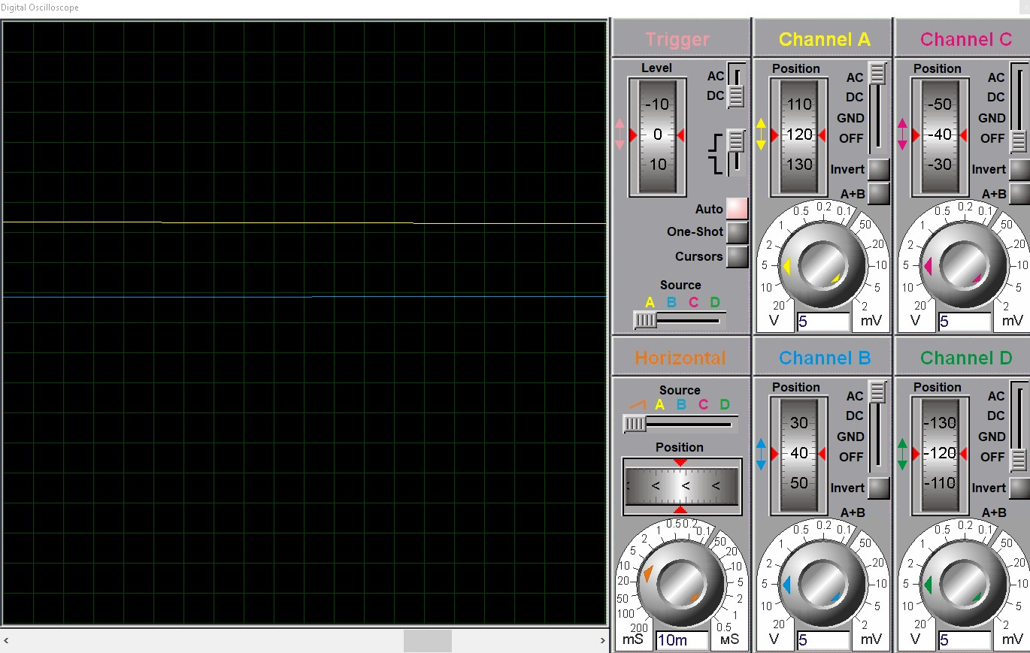
6Figure 3.6: Back-EMF Protection Oscilloscope Capture
Figure 3.6 Caption: Oscilloscope comparison of solenoid turn-off transients: (upper trace) unprotected coil showing 80V inductive spike; (lower trace) with 1N4007 flyback diode clamping voltage to 0.7V, demonstrating protection effectiveness for TIP122 transistor.
3.6.4.2 Stepper Motor Drivers (A4988)
Precise film feeding and auger metering require stepper motor control with microstepping capability. The A4988 stepper motor driver provides up to 1/16 microstepping, translating 200 full steps per revolution into 3200 microsteps for smooth motion and accurate positioning.
The A4988 incorporates internal current regulation, allowing motor current to be set via a sense resistor and reference voltage. This feature enables torque optimization while preventing motor overheating during continuous operation.

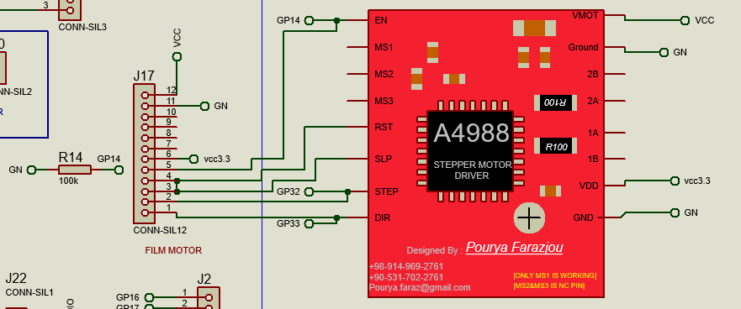
7Figure 3.7: A4988 Stepper Driver Interface Circuit
Figure 3.7 Caption: A4988 stepper motor driver interface showing STEP/DIR/ENABLE connections to ESP32 GPIO pins, current sense resistor configuration, and motor phase connections with decoupling capacitors on motor supply (VMOT) and logic supply (VDD).
Current limiting is essential for proper operation. The reference voltage and sense resistor determine the chopping current:
I_chop = V_ref / (8 x R_sense)
For the selected sense resistor of 43 mOhm and desired current of 1.5A:
V_ref = I_chop x 8 x R_sense
V_ref = 1.5A x 8 x 0.043 Ohm
V_ref = 1.5 x 8 x 0.043
V_ref = 0.516 V
This reference voltage is set via the onboard potentiometer on the A4988 module.

Parameter | Film Feed Motor | Auger Motor | Unit | Notes
STEP Pin | GPIO32 | GPIO25 | - | Step pulse input
DIR Pin | GPIO33 | GPIO26 | - | Direction control
ENABLE Pin | GPIO14 | GPIO27 | - | Active-low enable
Current Limit | 1.5 | 1.5 | A | Per phase
Sense Resistor | 43 | 43 | mOhm | Standard value
Reference Voltage | 0.516 | 0.516 | V | Set by trimpot
Microstepping | 1.0/16 | 1.0/16 | - | 3200 steps/revolution
Pull-down Resistor | 100 | 100 | kOhm | Ensures disabled at startup
4Table 3.4: A4988 Stepper Driver Configuration

Table 3.4 Caption: A4988 stepper driver configuration parameters for film feeding and auger metering systems, showing identical current settings with dedicated GPIO assignments and pull-down resistors for safe startup state.
The ENABLE pins incorporate 100 kOhm pull-down resistors to ensure motors remain de-energized during ESP32 boot-up, preventing uncontrolled motion before firmware initialization completes.
3.6.5 Solid State Relay Interface
Heater control for sealing jaws utilizes a Solid State Relay (SSR) interfaced to GPIO23. The SSR provides zero-cross switching to minimize electromagnetic interference and offers optical isolation between the 3.3V control circuit and the 220V AC heater load.
The interface includes a 330 Ohm current-limiting resistor for the SSR's internal LED and a 100 kOhm pull-down resistor to ensure heater remains off during system startup.

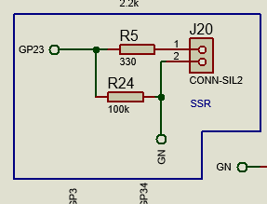
8Figure 3.8: SSR Control Interface Circuit
Figure 3.8 Caption: Solid State Relay control interface showing series current limiting resistor (330 Ohm) for internal optocoupler LED, pull-down resistor (100 kOhm) for default-off state, and connection to ESP32 GPIO23 for PWM-based temperature control.

3.6.6 PCB Design and Layout Considerations

3.6.6.1 Trace Width Calculations
Power distribution traces are sized according to IPC-2221B standards to prevent excessive heating and voltage drop. For the 12V motor supply carrying 2A maximum current, with 1oz copper thickness and 10 deg C temperature rise:
W = I / (k x delta_T^0.44)
W = 2 / (0.048 x 10^0.44)
W = 2 / (0.048 x 2.75)
W = 2 / 0.132
W = 0.76 mm
Where:
W = Minimum trace width (mm)
I = Current (2A)
k = Constant (0.048 for external layers)
delta_T = Temperature rise (10 deg C)
^0.44 = Raised to power of 0.44
A conservative width of 1.2mm is selected to provide safety margin and accommodate current spikes during motor acceleration.
Net | Current (A) | Calculated Width (mm) | Selected Width (mm) | Notes
VMOT (12V) | 2.0 | 0.76 | 1.20 | Motor supply with safety margin
VCC (5V) | 0.5 | 0.30 | 0.60 | Sensor supply
VDD (3.3V) | 0.3 | 0.20 | 0.40 | Logic supply
Signal | 0.01 | 0.15 | 0.30 | General purpose
GND Plane | - | - | Full pour | Return paths for all signals
5Table 3.5: PCB Trace Width Specifications

Table 3.5 Caption: PCB trace width calculations per IPC-2221B standard for 1oz copper with 10 deg C temperature rise, showing conservative design margins for reliability in industrial environments.

3.6.6.2 Thermal Management
Heat-generating components (A4988 drivers, TIP122 transistors) require thermal management to prevent junction temperatures exceeding maximum ratings. The A4988 in particular dissipates significant power during continuous operation:
P_diss = 2 x I_phase^2 x R_DS_on
P_diss = 2 x (1.5A)^2 x 0.32 Ohm
P_diss = 2 x 2.25 x 0.32
P_diss = 1.44 W
Where:
P_diss = Power dissipation (W)
I_phase = Phase current (1.5A)
R_DS_on = MOSFET on-resistance (0.32 Ohm)
^2 = Squared
Thermal vias (0.3mm diameter, plated) connect the exposed pad to copper pours on both PCB layers, providing heat spreading. With thermal resistance of approximately 30 deg C/W for the PCB arrangement, junction temperature is estimated as:
T_j = T_a + (P_diss x R_th_JA)
T_j = 50 deg C + (1.44W x 30 deg C/W)
T_j = 50 + 43.2
T_j = 93.2 deg C
Where:
T_j = Junction temperature (deg C)
T_a = Ambient temperature (50 deg C)
R_th_JA = Junction-to-ambient thermal resistance (30 deg C/W)
x = Multiplication
This remains below the 150 deg C maximum junction temperature with adequate margin.

3.6.6.3 Electromagnetic Compatibility
Noise suppression measures include:
100nF ceramic decoupling capacitors at each IC power pin
100uF electrolytic bulk capacitors at motor supply entry points
Ferrite beads on thermocouple leads for high-frequency filtering
Ground plane continuity with minimal slotting
Separation of high-current motor traces from sensitive analog signals

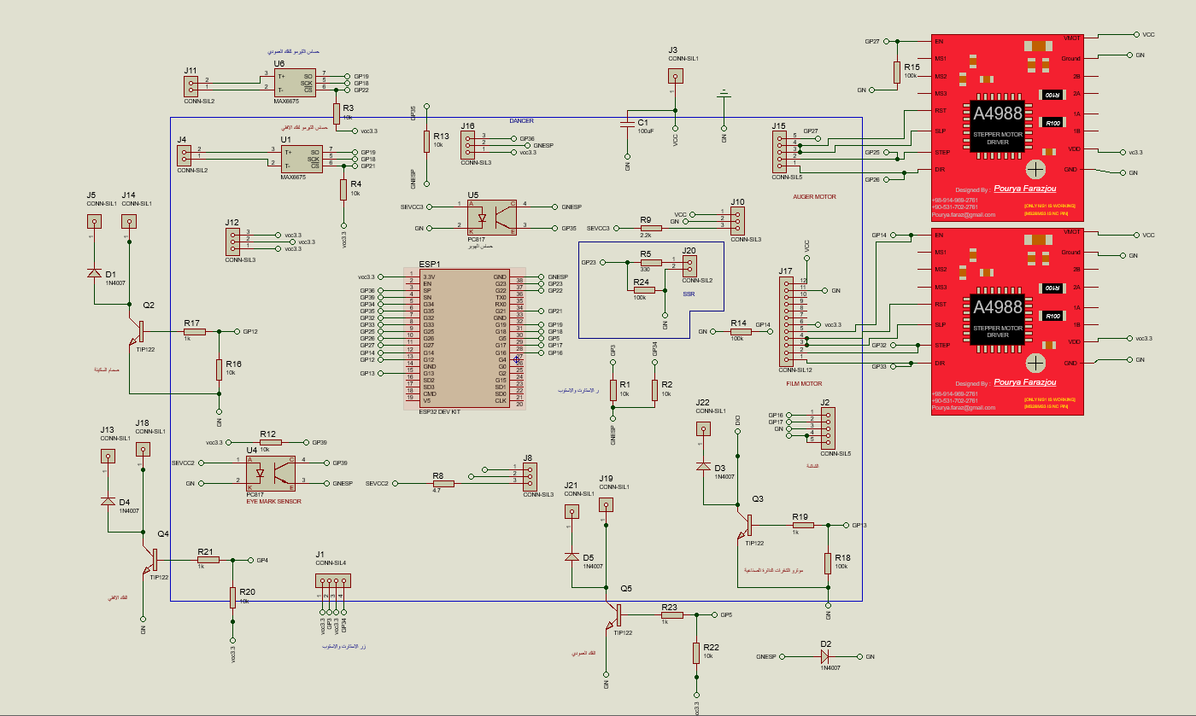
9Figure 3.9: PCB Layer Stack-up and Grounding Strategy
Figure 3.9 Caption: PCB layer stack-up showing top signal layer, internal ground plane, internal power plane, and bottom signal layer configuration with via stitching for ground continuity and electromagnetic interference reduction.

3.6.7 Power Budget and Distribution

Rail | Voltage (V) | Current (A) | Power (W) | Duty Cycle | Avg. Power (W)
VMOT (Motors) | 12 | 5.0 | 60.0 | 50.0% | 30.0
VCC (Sensors) | 5 | 0.04 | 0.2 | 100.0% | 0.2
VDD (Logic) | 3.3 | 0.14 | 0.45 | 100.0% | 0.45
Heater (SSR) | 220 | 2.0 | 440.0 | 25.0% | 110.0
**Total** | - | - | **500.65** | - | **140.65**
6Table 3.6: System Power Budget Analysis

Table 3.6 Caption: Comprehensive power budget for VFFS packaging machine showing peak and average power consumption across all voltage rails, with heater duty cycle based on thermal regulation requirements and motor duty cycle based on typical packaging cycle timing.
The selected power supply (MeanWell LRS-120-12, 120W) provides 15.96x margin over average consumption and 2.4x margin over peak non-heater loads, ensuring reliable operation with adequate headroom for inrush currents and supply degradation over time.

3.6.8 Safety and Protection Systems

3.6.8.1 Emergency Stop Implementation
Hardwired emergency stop functionality is implemented via GPIO34, configured as external hardware interrupt. The normally-closed mushroom button provides fail-safe operation: any wire break or button press immediately triggers interrupt service routine bypassing RTOS scheduler, forcing immediate stepper stop (RMT channel termination), heater disable (SSR off), and pneumatic valve closure.
Response time is specified below 50ms from button press to actuator de-energization, meeting ISO 13850 Category 0 stop requirements.
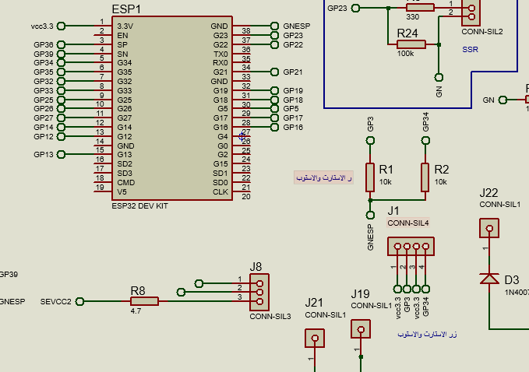
10Figure 3.10: Emergency Stop Circuit Implementation
Figure 3.10 Caption: Emergency stop circuit implementation showing normally-closed mushroom button with hardware pull-up, connection to ESP32 GPIO34 (external interrupt capable), and software response path ensuring Category 0 stop with under 50ms response time per ISO 13850.

3.6.8.2 Component Protection
Transient voltage suppression is implemented at multiple levels:
Metal Oxide Varistors (MOVs) on 24V power entry for surge protection
TVS diode arrays (SMBJ series) on 3.3V logic lines
Flyback diodes (1N4007) on all inductive loads
Fuse protection (F1-F3) for individual actuators
Location | Component | Rating | Function
24V Input | MOV | 30.0V | Surge voltage clamping
3.3V Logic | TVS Array | 5.0V | ESD and transient protection
Solenoid Coils | 1N4007 | 1A, 1000V | Back-EMF recirculation
Motor Drivers | Internal | 1.50A | Overcurrent limiting (A4988)
Heater Circuit | Fuse | 10.0A | Overcurrent protection
System Input | Circuit Breaker | 16.0A | Manual disconnect, short circuit
7Table 3.7: Protection Component Summary

Table 3.7 Caption: Protection component summary showing multi-level approach to system safety including surge suppression, transient voltage protection, inductive kickback prevention, and overcurrent protection for all critical circuits.

References
[1] Ulrich, K. T., & Eppinger, S. D. (2015). Product Design and Development (6th ed.). McGraw-Hill Education.
[2] INCOSE. (2015). Systems Engineering Handbook: A Guide for System Life Cycle Processes and Activities (4th ed.). Wiley.
[3] OIML. (2016). OIML R 87: Quantity of Product in Prepackages. International Organization of Legal Metrology.
[4] FDA. (2020). Current Good Manufacturing Practice in Manufacturing, Packing, or Holding Human Food. 21 CFR Part 110.
[5] Kuo, B. C., & Golnaraghi, F. (2003). Automatic Control Systems (8th ed.). John Wiley & Sons.
[6] Panasonic Industry. (2022). MINAS A6 Series AC Servo Motor Technical Reference. Panasonic Industry Europe GmbH.
[7] El Kassem, B. (2021). Machine Design for Auger Dosing of Powders by utilizing DEM Simulations. Ph.D. dissertation, RWTH Aachen University.
[8] Neugart GmbH. (2023). PLE Planetary Gearbox Technical Catalog. Neugart GmbH.
[9] Harris, C. M., & Piersol, A. G. (2002). Shock and Vibration Handbook (5th ed.). McGraw-Hill.
[10] Ellis, G. (2004). Control Systems for Machine Tools. John Wiley & Sons.
[11] Lorenz, R. D. (2000). Motion Control: Advanced Motion Control. In Wiley Encyclopedia of Electrical and Electronics Engineering.
[12] Heidenhain. (2022). Rotary Encoders: Technical Information. Dr. Johannes Heidenhain GmbH.
[13] Espressif Systems. (2023). ESP32 Technical Reference Manual. Espressif Systems.
[14] K. Ogata, Modern Control Engineering, 5th ed. Upper Saddle River, NJ, USA: Prentice Hall, 2010.
[15] K. J. Åström and T. Hägglund, Advanced PID Control. Research Triangle Park, NC, USA: ISA - The Instrumentation, Systems, and Automation Society, 2006.
[16] Espressif Systems, "ESP32 Technical Reference Manual," Version 4.8. [Online]. Available: https://www.espressif.com.
[17] Richard Barry, Mastering the FreeRTOS Real Time Kernel: A Hands-On Tutorial Guide. Real Time Engineers Ltd., 2016.
[18] A. Hughes and B. Drury, Electric Motors and Drives: Fundamentals, Types and Applications, 4th ed. Oxford, U.K.: Newnes, 2013.
[19] F. P. Incropera, D. DeWitt, T. Bergman, and A. Lavine, Fundamentals of Heat and Mass Transfer, 6th ed. Hoboken, NJ, USA: John Wiley & Sons, 2006.
[20] "LVGL - Light and Versatile Graphics Library," Open-source embedded GUI library. [Online]. Available: https://lvgl.io/.
[21] M. Groover, Automation, Production Systems, and Computer-Integrated Manufacturing, 4th ed. Pearson, 2014.

